SAILING INSTRUCTIONS – OPEN FLEETS
ARC REGATTA
July 22-23, 2023
Bedford Basin Yacht Club
377 Shore Drive, Bedford, NS B4A 2E7 Ph: 902.835.3729
www.bbyc.ca

RULES
Organizing Authority: Bedford Basin Yacht Club

  - The regatta will be governed by the rules as defined in The Racing Rules of Sailing (RRS).
  - RRS 40.1 applies at all times while afloat; BBYC’s marina is comprised of a series of floating docks.

CHANGES TO SAILING INSTRUCTIONS
Any change to the sailing instructions will be posted before 09:00 hours on the day it will take effect, except that any change to the schedule of races will be posted by 20:00 hours on the day before it will take effect.

COACHES MEETING
Coaches meeting will be held in place of a skippers meeting. The meeting will be held on the grass next to the clubhouse at 10:00 for Alpha and Bravo Fleets, and 10:15 for Charlie Fleet.

COMMUNICATIONS WITH COMPETITORS
  - Notices to competitors will be posted online at www.bbyc.ca. We will do our best to also post notices in the clubhouse windows along the front deck.
  - The race office and protest desk is located in the BBYC club on the main floor.
  - On the water, the race committee intends to monitor and communicate with support boats on VHF channels as below:

COURSE | CHANNEL
ALPHA | 71
BRAVO | 72
GREEN | 69

CODE OF CONDUCT
Competitors and support personnel shall comply with reasonable requests from race officials.

SIGNALS MADE ASHORE
  - Signals made ashore will be displayed on the mast at the BBYC clubhouse.
  - Signals made ashore over a course flag apply to that course only.
  - When code flag AP is displayed ashore, ‘1 minute’ is replaced with ‘not less than 60 minutes’ in race signal AP. This changes race signal AP.
  - Code flag L with one sound signal means a notice to competitors has been posted on the official notice board online.

SCHEDULE OF RACES
  - The scheduled time of the warning signal for the first race on both days is 11:30.
  - On any given day, the race committee (RC) shall run any number of races appropriate for the weather conditions, to a maximum of 10 for all fleets. All races after the first race of the day will be started as soon as is practical after the conclusion of the preceding race.
  - On the last day of the regatta no initial warning signal will be made after 15:00 hours.

COURSES AND CLASS FLAGS
  - Course assignments and class flags are:
CLASS | COURSE | CLASS FLAG
ILCA 6 (Laser Radial) | Alpha | White Flag with Red Class Insignia
ILCA 4 (Laser 4.7) | Alpha | Blue 4.7 flag
Optimist | Bravo | White Flag with Blue Class Insignia

CLASS | COURSE | CLASS FLAG
Club 420 | Bravo | White flag with Blue Class Insignia
ILCA 7 (Laser Radial) | Alpha | Red Flag with White Class Insigna

CLASS | COURSE | CLASS FLAG
Optimist Green | Charlie | Green R flag
420 Green | Charlie | White R flag

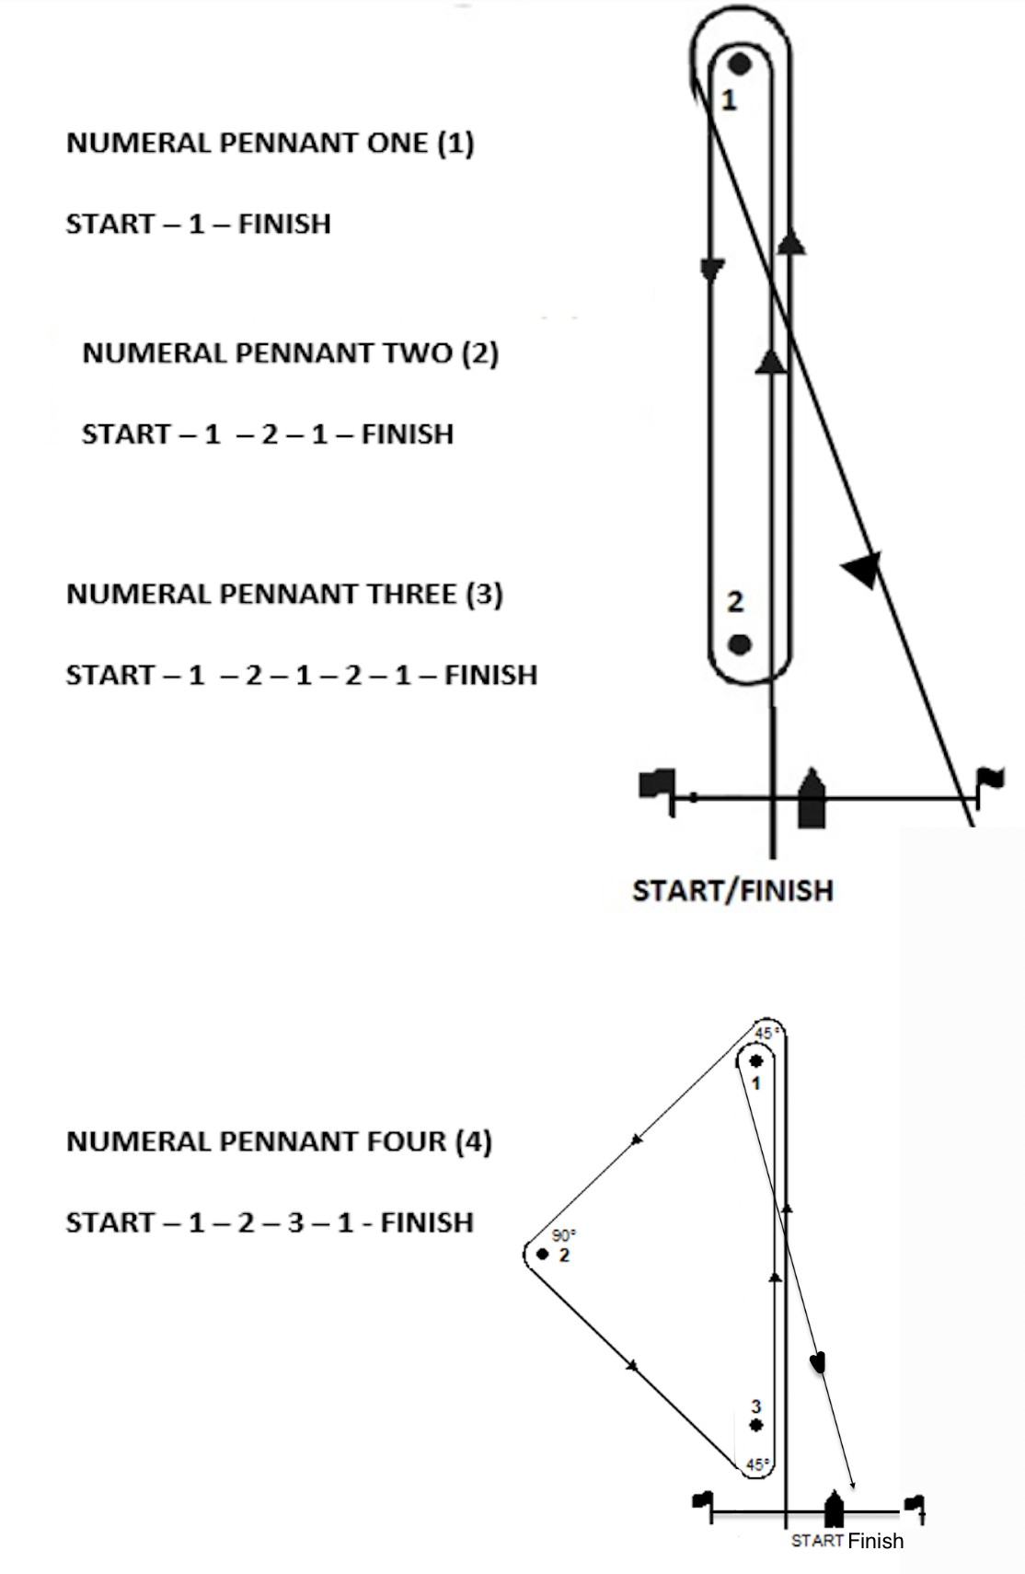
  - The diagrams below show the courses, including the approximate angles between legs, the order in which marks are to be passed, and the side on which each mark is to be left.

RACING AREAS
The diagram below shows the approximate location and size of racing areas in Bedford Basin. Anchored shipping may require locations to vary, but relative positions (Charlie nearest BBYC and Alpha farthest away) will be preserved.
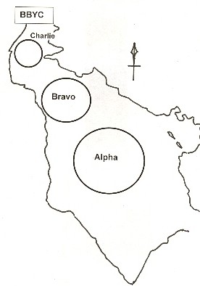

*Not for navigation

MARKS
  - For ILCA 6 (Laser Radial) and Opti Green, original mark 1 will be an inflated orange tetrahedron.
  - For ILCA 7 (Laser Standard), ILCA 4 (Laser 4.7), Optimists, and Club 420s, original mark 1 will be an inflated yellow tetrahedron.
  - 420 Greens Windward mark will be a yellow inflatable pin.
  - Leeward mark will be an inflated yellow tetrahedron for all classes excluding Opti Green and 420 Green which will have an orange tetrahedron
  - The start mark will be a yellow inflatable pin.
  - The finish mark will be a red mooring ball.
  - New marks, as provided in section 10.1, will be in a contrasting colour to the original mark.
  - Protection Marks that may be positioned astern of the RC Signal Boats will be marks of the course. Competitors shall not pass between the Protection Marks and the RC Signal Boats.

THE START
  - Races shall be started by using RRS Rule 26 with the warning signal made 5 minutes before the starting signal.
  - All categories (e.g.: ILCA 6, Club 420) within a class shall start together.
  - The starting line shall be between a mast or staff displaying an orange flag on the race committee signal boat at the starboard end and the course side of the port-end starting mark.
  - Boats whose warning signal has not been made shall avoid the starting area during the starting sequence for other races. The starting area is defined as that area within 50 metres of the start line. Failure to comply may result in a penalty at the discretion of the protest committee.
  - A boat starting later than 4 minutes after her starting signal will be scored Did Not Start without a hearing. This changes RRS Rules A5.1 and A5.2.

CHANGE OF THE NEXT LEG OF THE COURSE
To change the next leg of the course, the RC will lay a new mark or move the finishing line and remove the original mark as soon as practicable. When in a subsequent change a new mark is replaced, it will be replaced by an original mark.
  - The change mark for an orange tetrahedron will be substituted with an orange tetrahedron with a black stripe.
  - The change mark for a yellow tetrahedron will be substituted with an orange cylinder.

THE FINISH
The finishing line shall be between the mast or staff displaying a blue flag on a race committee boat and the course side of the finish mark which will be a red mooring ball.

PENALTY SYSTEM
  - Appendix P applies, except that rule P2.3 is deleted and rule P2.2 is changed so that it will apply to any penalty after the first.

TIME LIMIT AND TARGET TIMES
  - Time limits and target times are as follows:
Class | Mark 1 Time Limit | Race Time Limit | Target Time
420 Green | 30 minutes | 60 minutes | 40 minutes
Optimist Green | 30 minutes | 60 minutes | 40 minutes
ILCA 7 (Laser) | 30 minutes | 60 minutes | 40 minutes
ILCA 4 (Laser 4.7) | 30 minutes | 60 minutes | 40 minutes
ILCA 6 (Laser Radial) | 30 minutes | 60 minutes | 40 minutes
Club 420 | 30 minutes | 60 minutes | 40 minutes
Optimist Open | 30 minutes | 60 minutes | 40 minutes

  - If no boat has passed Mark 1 within the Mark 1 time limit the race shall be abandoned. Failure to meet the target time shall not be grounds for redress. This changes rule 62.1(a).
  - Boats failing to finish within 20 minutes after the first boat sails the course and finishes will be scored Did Not Finish (DNF) without a hearing.
  - For Optimist & 420 Green competitors, the Race Committee may award finishing places to boats that are delaying the finish of the race. Finishing positions will be awarded based on the current position of boats and they will be designated OCF, the scoring abbreviation for an on-course finish. This changes rules 28.1, 35, A4, A5, and A11.

PROTESTS AND REQUESTS FOR REDRESS
  - For each class, the protest time limit is 60 minutes after the RC Signal boat has docked. The time will be posted on the online official notice board.
  - Hearing request forms are available at the race office / protest desk in the downstairs wardroom. Protests and requests for redress or reopening shall be delivered there within the appropriate time limit.
  - Notices will be posted no later than 30 minutes after the protest time limit to inform competitors of hearings in which they are parties or named as witnesses. Hearings will be held in the protest room, whose location will be identified online, beginning at the time posted.
  - Notices of protests by the race committee or protest committee will be posted to inform boats under rule 61.1(b).
  - Race committee will post a summary of race committee actions on the official online notice board upon docking each day.
  - Scoring inquiry forms are available in the upstairs wardroom.
  - A list of boats that, under instruction 12.2, have been penalized for breaking rule 42 will be posted on the notice board.
  - Breaches of instructions 16, 18, and 19 will not be grounds for a protest by a boat. This changes rule 60.1(a).
  - Penalties for breaking a rule other than the rules of RRS Part 2, Rule 31 or 42 will be determined by the protest committee. The changes Rule 64.2. The scoring abbreviation for a penalty imposed under this instruction will be DPI.

SCORING
  - One race is required to constitute a series.
  - When fewer than 5 races have been completed, a boat’s series score will be the total of its race scores.
  - When 5 or more races have been completed, a boat’s series score will be the total of its races scored excluding its worst score.
  - There will be a maximum of 10 races.

SAFETY REGULATIONS
  - Before their first race of the day, each boat shall sail on starboard tack across the stern of the RC signal boat and hail their sail number and receive acknowledgement. Each boat shall stay clear of the stern after checking in.
  - A boat that retires from a race shall notify the race committee as soon as possible.

REPLACEMENT OF CREW
Substitution of competitors is permitted but requires prior completion or amendment of registration documents.

SUPPORT BOATS
  - Team leaders, coaches and other support personnel shall stay outside areas where boats are racing from the time of the preparatory signal for the first class to start until all boats have finished or retired or the RC signals a postponement, general recall, or abandonment. Except in responding to safety concerns, support boats shall maintain a distance of at least 50 metres from any competitor and shall not interfere with the functions of the RC or Jury boats. Penalties may be applied to the support boat or its associated competitor boat(s) at the discretion of the protest committee.
  - Support boats shall be marked with an orange ribbon and are required to carry a marine VHF radio tuned to the required frequency and are required to be available in case of emergency.
  - Except in an emergency, a boat shall neither make radio transmissions while racing nor receive radio communications not available to all boats. This restriction also applies to mobile phones and other devices capable of receiving email, text or other electronic forms of communication.

SAIL NUMBERS
  - Sail numbers shall be legible and shall match those on the boat’s registration form. Boats whose sail numbers do not correspond to those at registration will not be scored.
  - In the event that duplicate sail numbers are registered in any class, the Race Committee may require one of the numbers to be changed before racing. Priority will be given to preserving hull and sail number matches.

PRIZES
Prizes will be awarded to 1st, 2nd, and 3rd place in all open classes. Other awards may be provided at the OA’s discretion.

DISCLAIMER OF LIABILITY
Competitors participate in the regatta entirely at their own risk. See Rule 4, Decision to Race. The OA will not accept any liability for material damage, personal injury or death sustained in conjunction with, prior to, during or after the regatta.

TRASH DISPOSAL
Boats shall not put trash in the water. Coach boats, race committee boats and all other support boats will accept trash.

RISK STATEMENT
RRS 3 states: ‘The responsibility for a boat’s decision to participate in a race or to continue to race is hers alone.’ By participating in this event each competitor agrees and acknowledges that sailing is a potentially dangerous activity with inherent risks. These risks include strong winds and rough seas, sudden changes in weather, failure of equipment, boat handling errors, poor seamanship by other boats, loss of balance on an unstable platform and fatigue resulting in increased risk of injury. Inherent in the sport of sailing is the risk of permanent, catastrophic injury or death by drowning, trauma, hypothermia or other causes.

